Create the database insurance
- create database insdb;
Use the database
- use insdb;
Create tables with relationships
- create table customers (cusid int constraint c_id primary key, fname nchar(10), lname nchar(10), dob date, phoneno int, email varchar(20))
- create table polices (policyid int constraint p_id primary key, policyname nchar(10), policyty nchar(10), pream int, durationyrs int)
- create table claims(claimid int primary key, assid int, claimdate date, claimamt int, claimstatus nchar(10))
- create table policyassignments(assid int primary key, customerid int foreign key references customers(cusid),polid int constraint fk_p foreign key references polices(policyid), agid int foreign key references agents(agenid),startdate date, enddate date)
- create table agents(agenid int primary key, aname nchar(10), phone int, city nchar(10))
4.
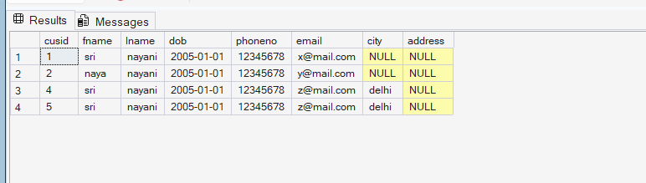
1. select * from customers

2. select customerid,polid,agid,startdate,enddate from policyassignments
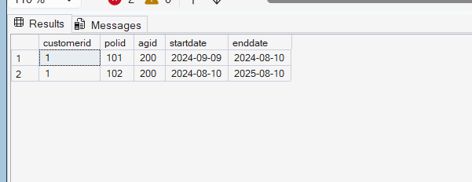

3.select * from polices where policyname='health'
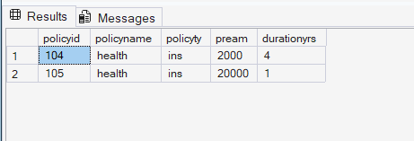
4.select * from polices where pream>10000 and durationyrs=1;
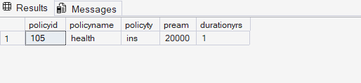
5.select distinct city from agents
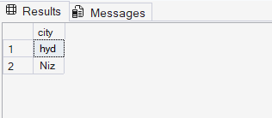
6.select * from polices where policyname='health' or policyname='home'
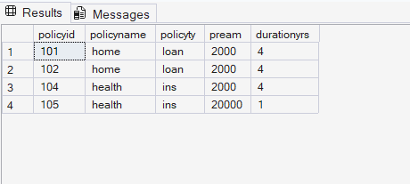
7.select * from polices where policyname in ('health','home','vehicle');
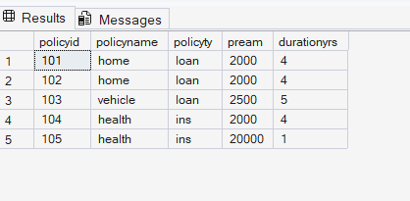
8.select * from customers where dob>='2005-01-01' and dob<='2005-05-10'
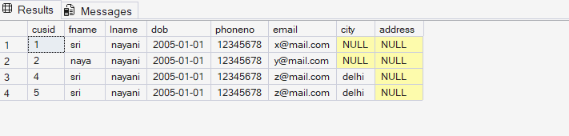
9.select * from customers where dob between '2005-01-01' and '2005-05-10'
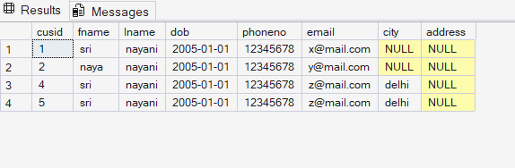
10.select * from claims where claimstatus='Rejected'
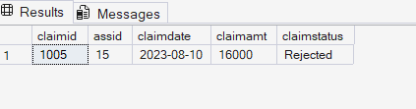
11.select * from claims where claimid=(select max(claimid) from claims);
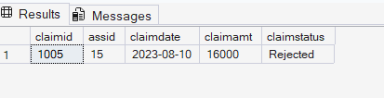
12.select min(claimamt),max(claimamt) from claims
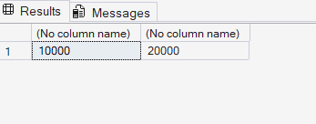
13.select * from agents where city is not null and aname like '_a%'
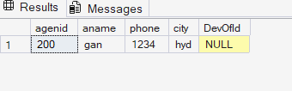
14.select policyid,pream+pream*0.1 as new_pream from polices where policyname='health'
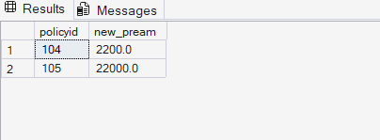
15.insert into policyassignments values(308,1,102,200,'2024-08-10','2025-12-30')
select * from policyassignments where enddate>GETDATE();
delete from policyassignments where enddate>GETDATE();
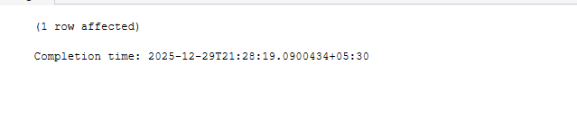
16.select count(*) from claims where claimstatus='Rejected'
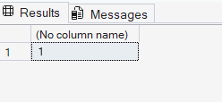
17.alter table agents add DevOfId int;

18. alter table customers add address varchar(20);
alter table customers add city varchar(10)
19. alter table agents
add constraint fk_agents_devofid
foreign key (devofid)
references agents(agenid);

20.select
policyid,
policyname,
pream,
pream * 0.06 as localtaxes,
pream + (pream * 0.06) as premiumamountwithtax,
pream / 12.0 as monthlypremiumamount
from polices;
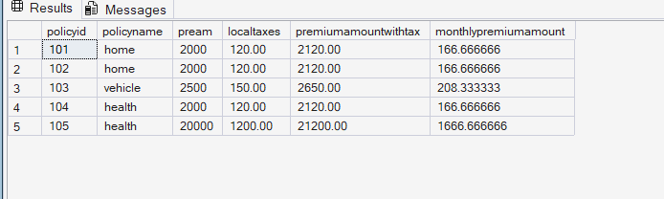

5.
1. select p.policyid,p.policyname from polices p join policyassignments pa
on p.policyid=pa.polid where pa.customerid=5
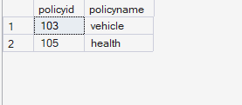
2. select c.cusid,p.policyname from polices p join policyassignments pa
on p.policyid=pa.polid join customers c on pa.customerid=c.cusid
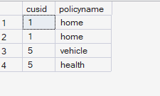
3.select c.lname,cl.claimamt, cl.claimstatus
from customers c
join policyassignments pa on c.cusid = pa.customerid
join claims cl on pa.assid = cl.asssid;
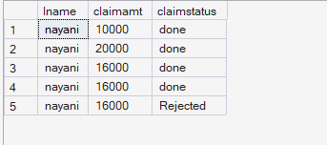
4. select c .fname,p.policyname,a.aname, pa. startdate, pa. enddate
from policyassignments pa
join customers c on pa.customerid = c.cusid
join polices p on pa.polid = p.policyid
join agents a on pa.agid = a.agenid;
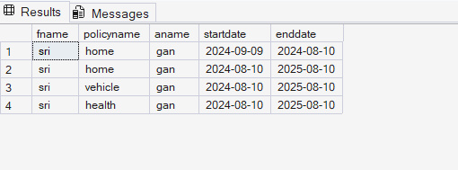
5. select c.fname,p.policyname,cl. claimamt,cl.claimstatus, cl.claimdate
from claims cl
join policyassignments pa on cl.asssid = pa.assid
join customers c on pa.customerid = c.cusid
join polices p on pa.polid = p.policyid;
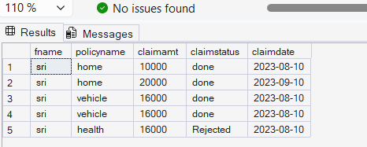
6. select c.cusid, c.fname, p.policyname
from customers c
left join policyassignments pa on c.cusid = pa.customerid
left join polices p on pa.polid = p.policyid;
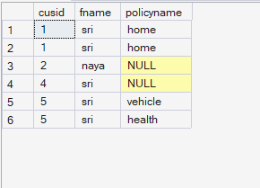
7. select c.cusid, c.fname
from customers c
left join policyassignments pa on c.cusid = pa.customerid
left join claims cl on pa.assid = cl.asssid
where cl.claimid is null;
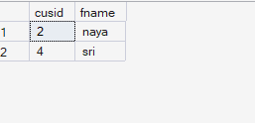
8.
select c.fname, sum(cl.claimamt) as totalclaimamount
from customers c
join policyassignments pa on c.cusid = pa.customerid
join claims cl on pa.assid = cl.asssid
group by c.fname;
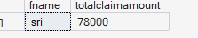
9. select c.fname, sum(cl.claimamt) as totalclaimamount
from customers c
join policyassignments pa on c.cusid = pa.customerid
join claims cl on pa.assid = cl.asssid
group by c.fname
having sum(cl.claimamt) > 50000
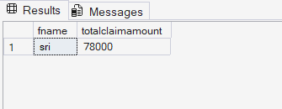
10. select a.aname,count(pa.polid) as policycount
from agents a
join policyassignments pa on a.agenid = pa.agid
group by a.aname;
